Scenario 3: if you need to change the password complexity or password expiration.
Step 1: IAM > account settings>Custom
Step 2: select the complexity that you required
Step 3: Add expiration day.
Here for the testuser I have selected password expiration requires administrators reset.
So for example, I have selected expiration for 1 day
29th 16:29 password should change after 1day 30th 16:29
LETS SEE THE CHANGE, I WILL POST HERE.
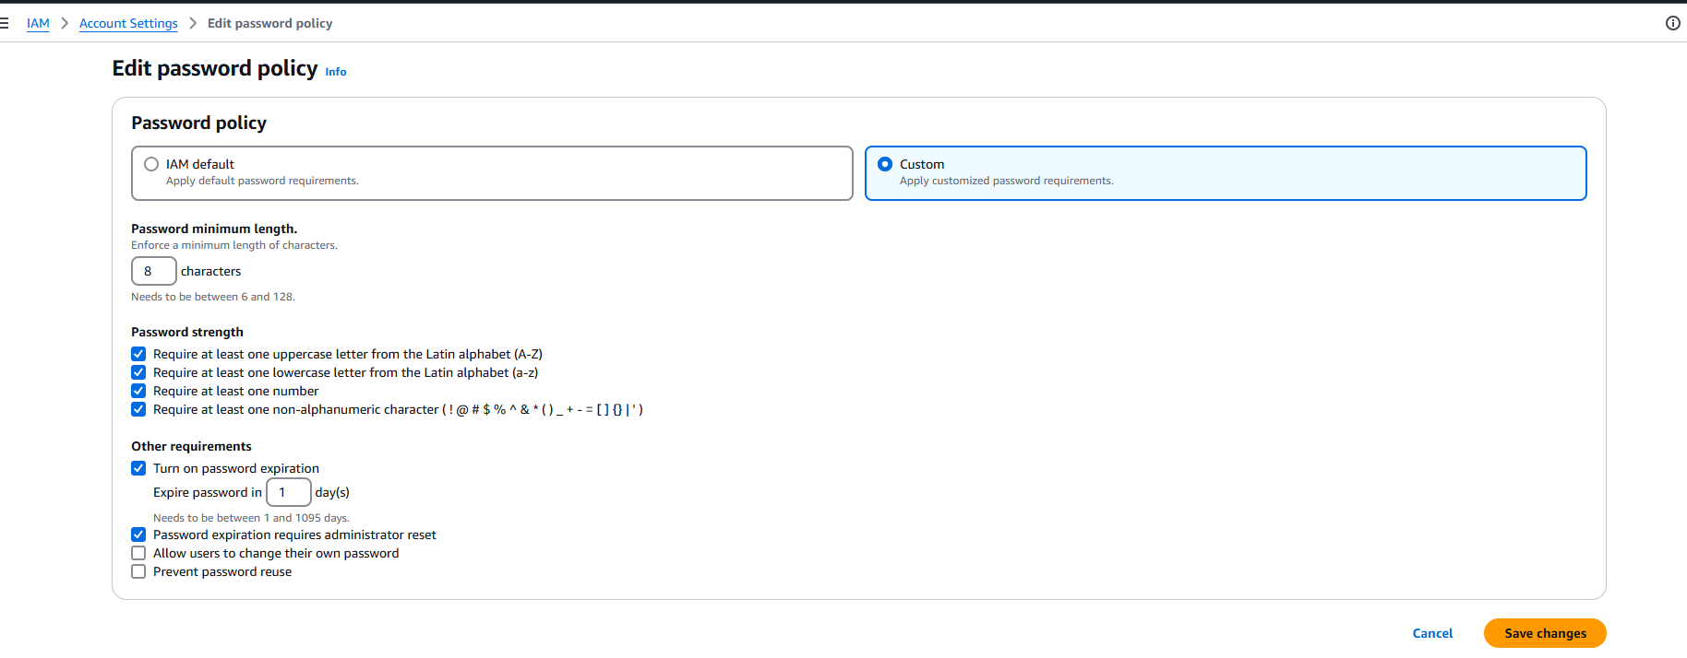
Yes , indeed the password got expired , it asked for reset
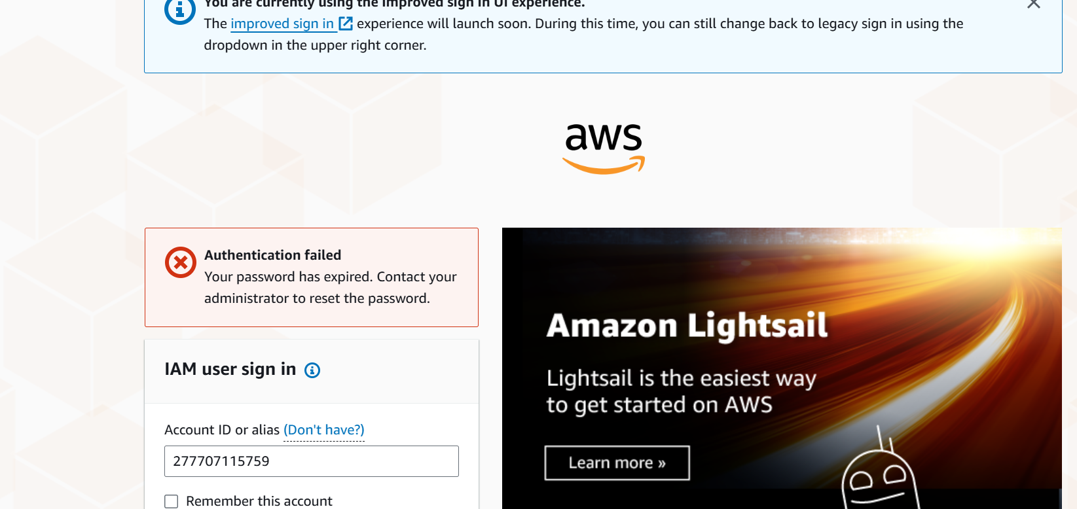
Step 1 : IAM > users >locate the user
Navigate to security credentials > manage console access
